Internet and Web Programming

Cyclesheet I

Shakthi T | 19BCE2355 | Shakthi.t2019@vitstudent.ac.in

# Question 1)

**Code**:

<!DOCTYPE html>

<html lang="en" dir="ltr">

<head>

<style>

body {

text-align: center;

background-color: yellow;

}

.Name {

color: #75cfb8;

}

</style>

<meta charset="utf-8">

<title>Question 1</title>

</head>

<body>

<div class="Name">

<marquee><h2 style="font-family:verdana">Shakthi T</h2></marquee>

<h3 style="font-family:'Courier New'">19BCE2355</h3>

</div>

<div class="numbers">

<p style="color: powderblue;">1</p>

<p style="color: tomato;">2</p>

<p style="color: CadetBlue;">3</p>

<p style="color: Coral;">4</p>

<p style="color: Crimson;">5</p>

<p style="color: DarkSlateBlue;">6</p>

<p style="color: DodgerBlue;">7</p>

<p style="color: MediumSpringGreen;">8</p>

<p style="color: Plum;">9</p>

<p style="color: Thistle;">10</p>

</div>

<div class="Lorem">

<p>

<font face="Courier New">

Lorem Ipsum is simply dummy text of the printing and typesetting industry.

</font>

<font face="Times New Roman">

Lorem Ipsum has been the industry's standard dummy text ever since the 1500s, when an unknown printer took a galley of type and scrambled it to make a type specimen book.

</font>

<font face="Helvetica">

It has survived not only five centuries, but also the leap into electronic typesetting, remaining essentially unchanged.

</font>

<font face="Georgia">

It was popularised in the 1960s with the release of Letraset sheets containing Lorem Ipsum passages, and more recently with desktop publishing software like Aldus PageMaker including versions of Lorem Ipsum.

</font>

</p>

</div>

<div class="Des">

<p>

<u>The Street Lawyer</u> by <u>John Grisham</u>. This book is about a lawyer who begins re-evaluating his priorities in life when a bad

incident occurs within his law firm. Consequently, he becomes acquainted with the inner city streets, and realizes the harsh existence of the homeless, and vows to give them a chance in the courts. <u>The Street Lawyer</u> is a

<b><i>great</i></b>

book. It is <b><i>well written</i></b> and <b><i>interesting</i></b>. Other books by <u>John Grisham</u> include <u>The Firm</u>, <u>The Pelican Brief</u>, and <u>The Client</u>.

</p>

</div>

<div class="Headname">

<h6>S</h6>

<h5>h</h5>

<h4>a</h4>

<h3>k</h3>

<h2>t</h2>

<h1>h</h1>

<h1>i</h1>

</div>

<div class="comment">

<!-- This is a comment -->

</div>

<pre class="c-exec" style="max-height: 600px; position: relative;">

<code class="c hljs cpp"><span class="hljs-meta">#<span class="hljs-meta-keyword">include</span> <span class="hljs-meta-string">&lt;stdio.h&gt;</span></span>

<span class="hljs-function"><span class="hljs-keyword">int</span> <span class="hljs-title">main</span><span class="hljs-params">()</span> </span>{

<span class="hljs-keyword">int</span> number;

<span class="hljs-built_in">printf</span>(<span class="hljs-string">"Enter an integer: "</span>);

<span class="hljs-built_in">scanf</span>(<span class="hljs-string">"%d"</span>, &amp;number);

<span class="hljs-built_in">printf</span>(<span class="hljs-string">"You entered: %d"</span>, number);

<span class="hljs-keyword">return</span> <span class="hljs-number">0</span>;

}

</code><div class="open_grepper_editor" title="Edit &amp; Save To Grepper"></div></pre

</html>

**Output:**

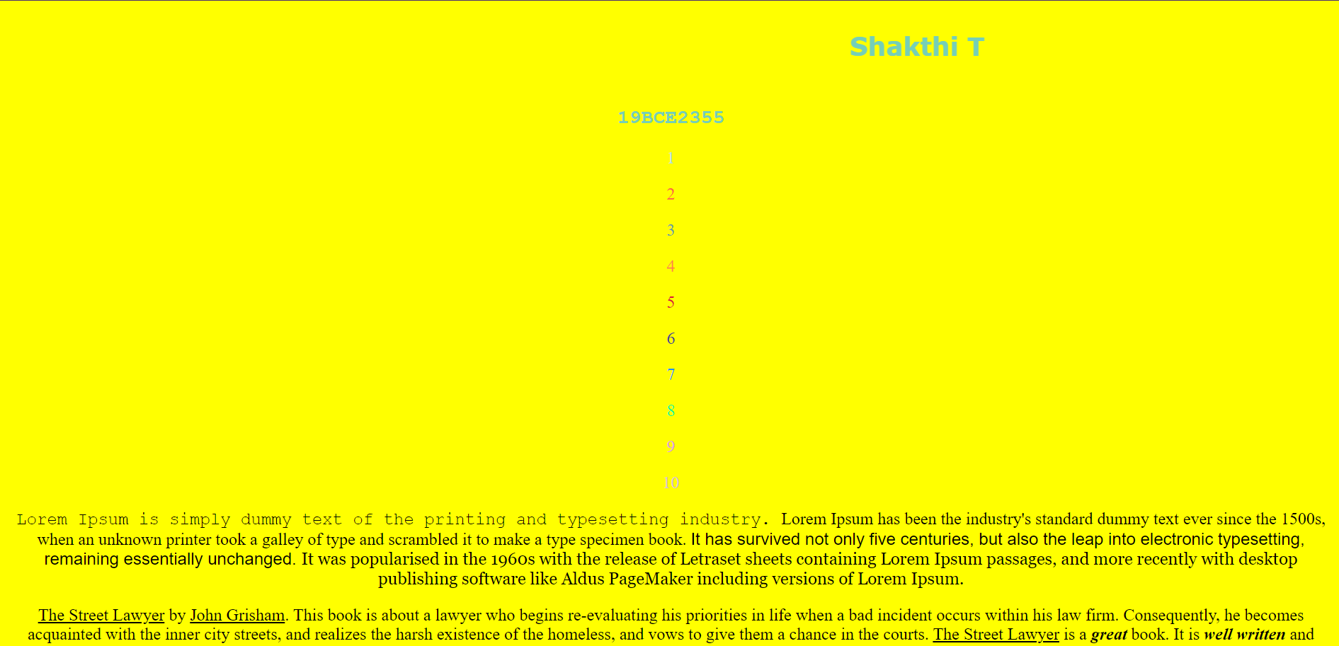

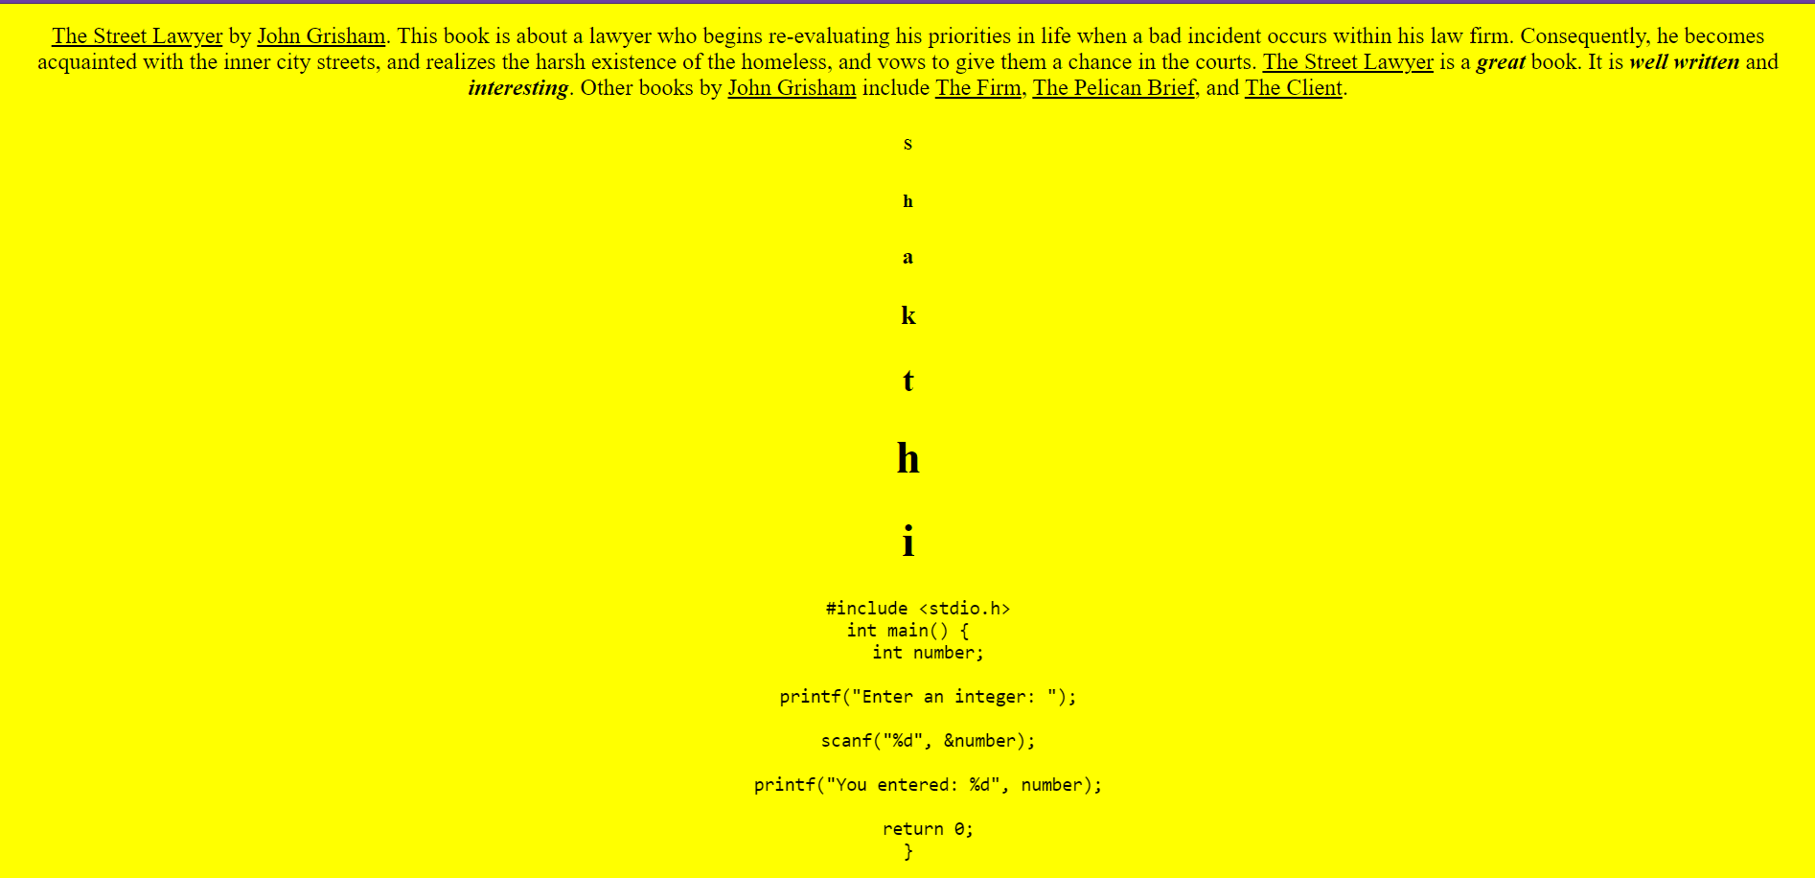

## Question 2)

**Code:**

Code:

<!DOCTYPE html>

<html lang="en" dir="ltr">

<head>

<meta charset="utf-8">

<title>About Me</title>

<link rel="stylesheet" href="styleme.css">

<style>

ul,ol{

text-align: center;

list-style-position: inside;

}

</style>

</head>

<body>

<center>

<h1>Shakthi T</h1>

<p>5/65, Sea View Avenue,2nd Cross Street, Chennai - 41</p> <br>

<h2>Description</h2>

<p>I am Second year <b>Sophmore</b> at VIT Vellore and a Professional <b>Web Developer.</b></p>

<br>

<h2>Subjects</h2>

<ul>

<li style="color:#ff9292" ;>Internet and Web programming - Learning to Build Websites </li>

<li>Java Programming - Learning to Code in Java</li>

<li>Operations Management - Learning to Deal with Opearations in a company</li>

</ul>

<h2>TV Shows</h2>

<ol>

<a href="https://www.imdb.com/title/tt0108778/">

<li>Friends</li>

</a>

<li>Brooklyn Nine Nine</li>

<li>Lucifer</li>

</ol>

<h3>When I'm happy</h3>

<img src="https://happyologist.co.uk/wp-content/uploads/happy.jpeg" height="120px" width="150px" alt="Happy Image">

<h3>When I'm Sad</h3>

<img src="https://media3.s-nbcnews.com/j/newscms/2019_42/1495563/sadness-inside-out-today-main-tease-191018_010305cfdd8f7dab2c6547daadfcfce6.fit-2000w.jpg" height="120px" width="150px" alt="Sad Image">

<h2>Neighbour</h2>

<p>He is very funny and jovial. Always makes sure everyone around him has a good time.</p>

<h2>Skill Level</h2>

<ul>

<li>C - 95%</li>

<li>C++ - 95%</li>

<li>Python - 80%</li>

<li>Javascript - 95%</li>

<li>Java - 75%</li>

</ul>

</center>

</body>

</html>

**Output:**

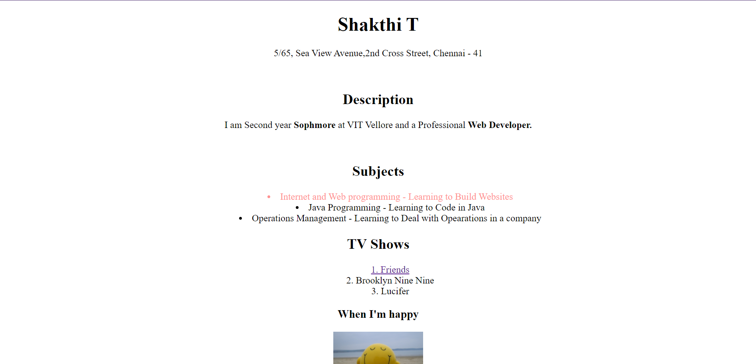

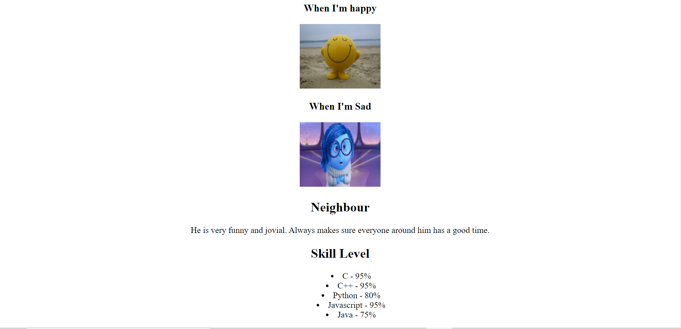

## Question 3**A)**

**Code:**

<!DOCTYPE html>

<html lang="en" dir="ltr">

<head>

<meta charset="utf-8">

<title>Question 3</title>

</head>

<body>

<h1>Unalphabetized list</h1>

Bill<sub>3</sub>

<br />

Roger<sub>5</sub>

<br />

Sandra<sub>6</sub>

<br />

Stacy<sub>7</sub>

<br />

William<sub>10</sub>

<br />

Thomas<sub>8</sub>

<br />

Wendy<sub>9</sub>

<br />

Jane<sub>4</sub>

<br />

Andy<sub>1</sub>

<br />

Anna<sub>2</sub>

<h1>Alphabetized list</h1>

Andy

<br />

Anna

<br />

Bill

<br />

Jane

<br />

Roger

<br />

Sandra

<br />

Stacy

<br />

Thomas

<br />

Wendy

<br />

William

</body>

</html>

**Output:**

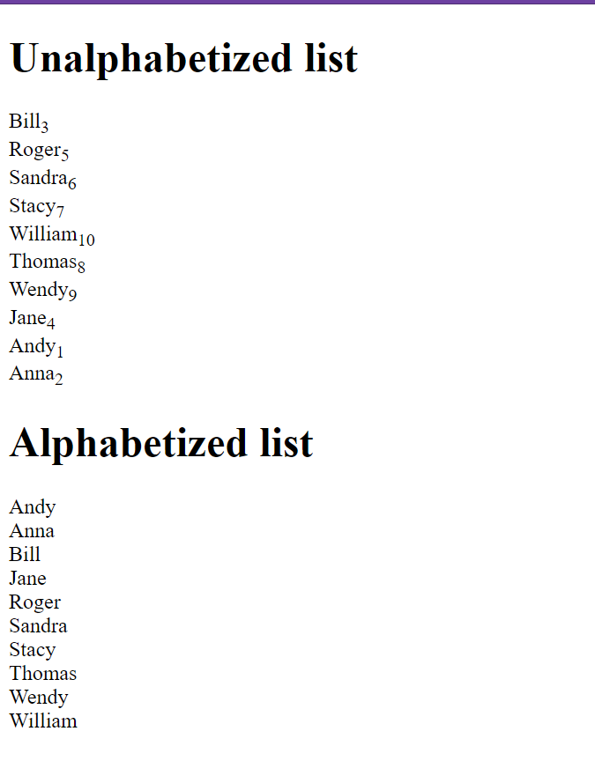

<!DOCTYPE html>

<html lang="en" dir="ltr">

<head>

<meta charset="utf-8">

<title>Question 3</title>

</head>

<body>

<h1>Unalphabetized list</h1>

Bill<sub>3</sub>

<br />

Roger<sub>5</sub>

<br />

Sandra<sub>6</sub>

<br />

Stacy<sub>7</sub>

<br />

William<sub>10</sub>

<br />

Thomas<sub>8</sub>

<br />

Wendy<sub>9</sub>

<br />

Jane<sub>4</sub>

<br />

Andy<sub>1</sub>

<br />

Anna<sub>2</sub>

<h1>Alphabetized list</h1>

Andy

<br />

Anna

<br />

Bill

<br />

Jane

<br />

Roger

<br />

Sandra

<br />

Stacy

<br />

Thomas

<br />

Wendy

<br />

William

</body>

</html>

**Output:**

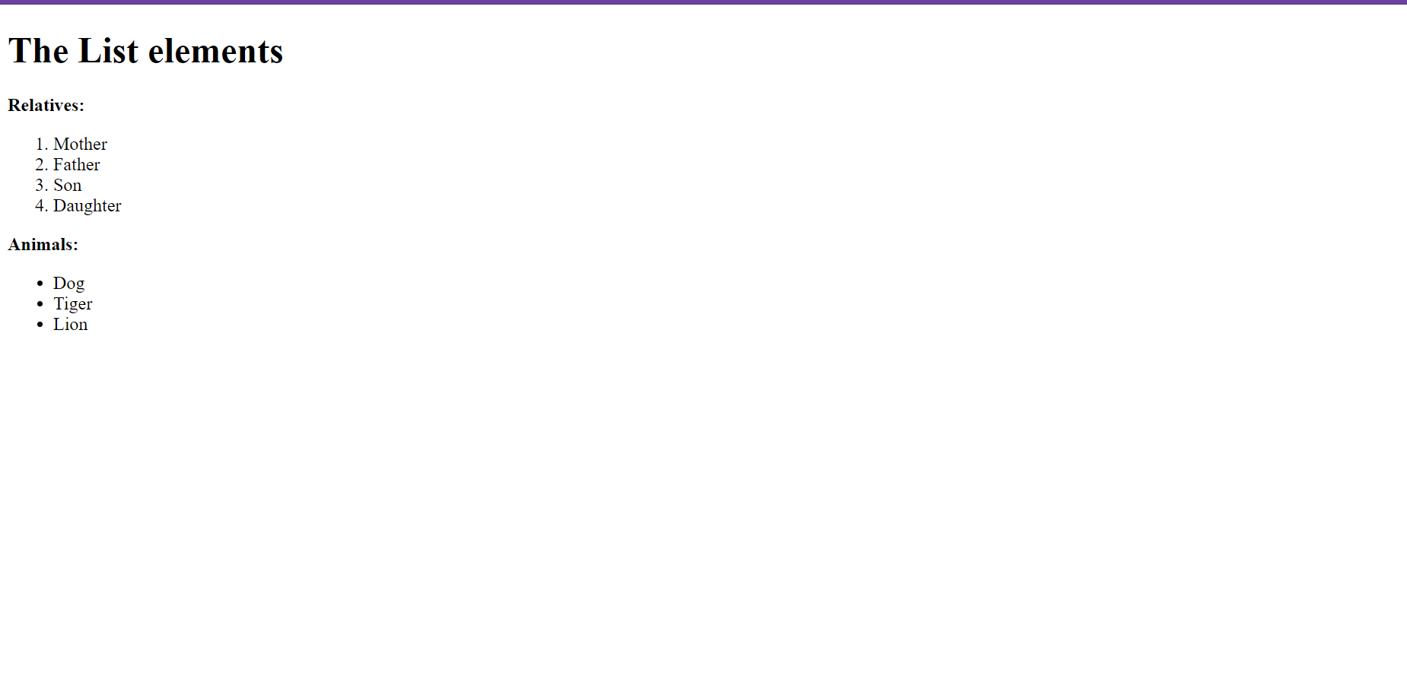

# 3c)

**Code:**

<!DOCTYPE html>

<html lang="en" dir="ltr">

<head>

<meta charset="utf-8">

<title></title>

</head>

<body>

<ol type="i" start="7">

<li>seventh item</li>

<li>eighth item</li>

<li>ninth item</li>

</ol>

</body>

</html>

**Output:**

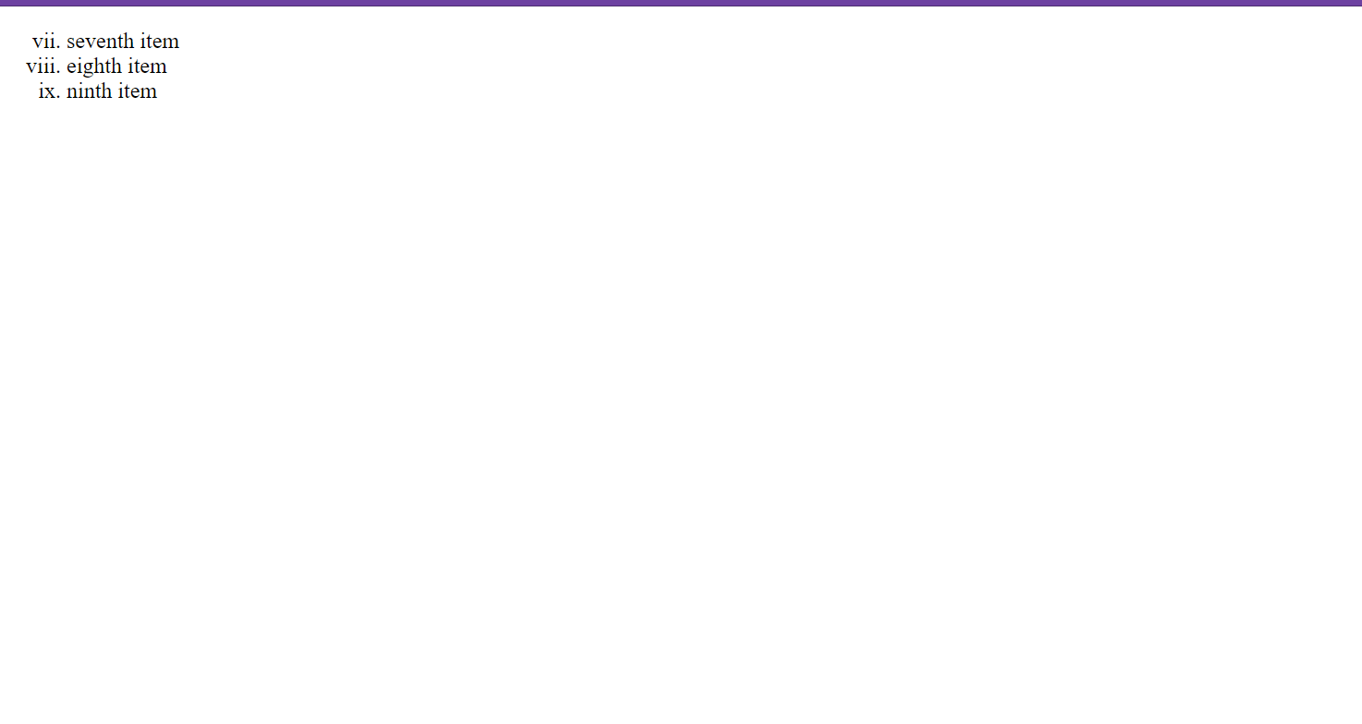

# Question 3D)

**Code:**

<!DOCTYPE html>

<html lang="en" dir="ltr">

<head>

<meta charset="utf-8">

<title>Question3</title>

</head>

<body>

<address>

Shakthi T<br />

South Street<br />

Chennai - 600041

</address>

<br> <br>

<center>

<address>

XXXX<br />

North Street<br />

Coimbatore - 20

</address>

</center>

</body>

</html>

**Output:**

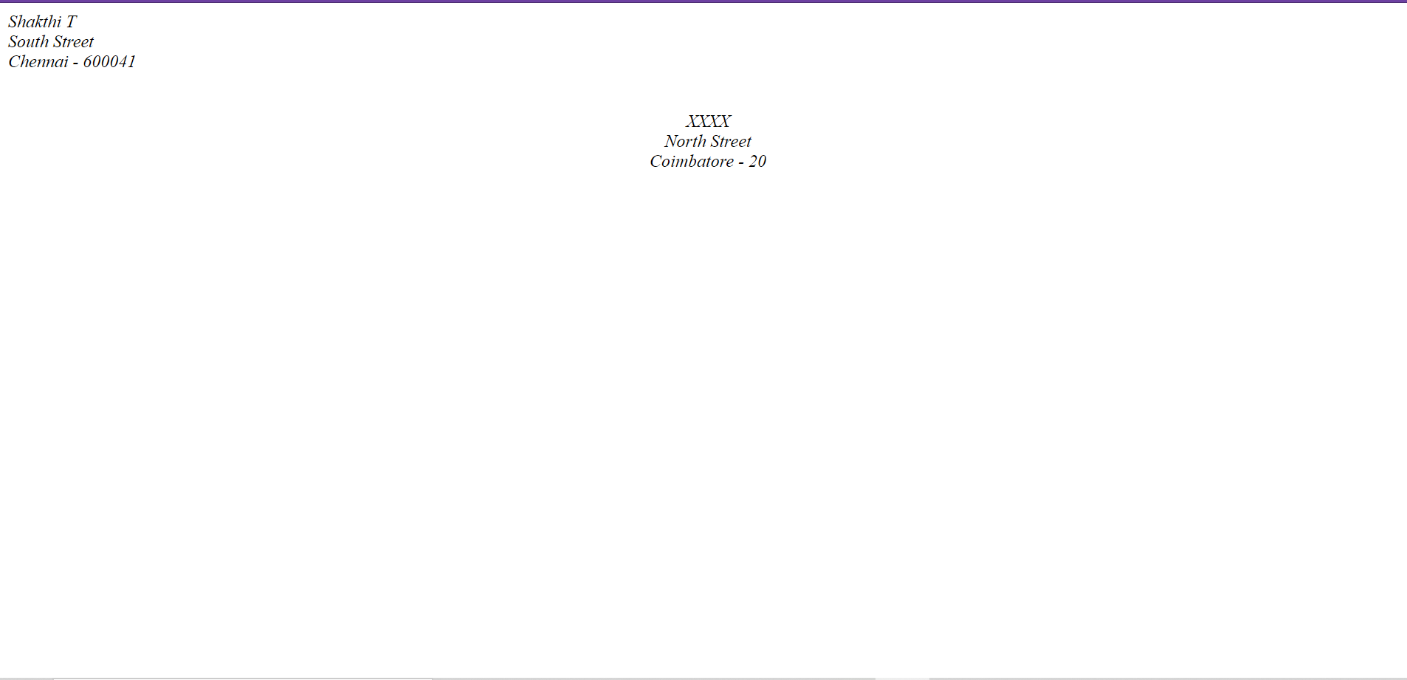

# Question 3E)

Code:

<!DOCTYPE html>

<html lang="en" dir="ltr">

<head>

<meta charset="utf-8">

<title>Question3e</title>

</head>

<body>

<html>

<body>

<abbr title="Computer Science">CSC.</abbr>

<br /><br />

<abbr title="Internet and Web Programming">IWP</abbr>

<br /><br />

<abbr title="Operating Systems">OS</abbr>

<br /><br />

<abbr title="Statistics">Stats</abbr>

<br /><br />

<acronym title="Institute of Electrical

and Electronic Engineers">IEEE</acronym>

<br /><br />

</body>

</html>

</body>

</html>

Output:

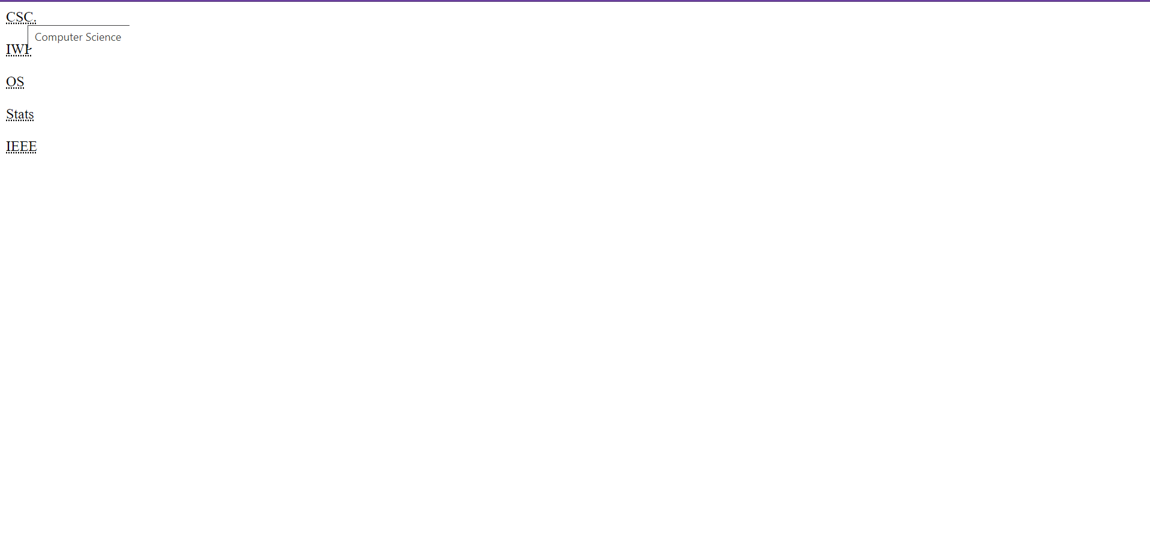

# Question 4)

Code:

<!DOCTYPE html>

<html>

<head>

<title>Table</title>

<style>

table{

border: 3px solid grey;

border-spacing: 3px;

}

td, th {

border: 1px solid grey;

}

</style>

</head>

<body>

<center><table>

<tr>

<th colspan="4"><b>Purchased Equipments (June, 2006)</b></th>

</tr>

<tr>

<td rowspan="2"><b>Item Num#</b></td>

<td rowspan="2"><b>Item Picture</b></td>

<td><b><center>Item Description</center></b></td>

<td><b><center>Price</center></b></td>

</tr>

<tr>

<td><b>Shipping Handling, Installaiton, etc</b></td>

<td><b>Expense</b></td>

</tr>

<tr>

<td rowspan="2">1.</td>

<td rowspan="2"><img src="https://www.allaboutcircuits.com/uploads/articles/Ibm_pc_5150.jpg" width="100" height="100"></img></td>

<td>IBM Clone Computer.</td>

<td>$ 400.00</td>

</tr>

<tr>

<td>Shipping Handling, Installaiton, etc</td>

<td>$ 20.00</td>

</tr>

<tr>

<td rowspan="2">2.</td>

<td rowspan="2"><img src="https://images.exxactcorp.com/productimages/med_lrg/EXX-IMG-757337.jpg" width="100" height="100"></img></td>

<td>1GB RAM Module for Computer</td>

<td>$ 50.00</td>

</tr>

<tr>

<td>Shipping Handling, Installation, etc</td>

<td>$ 14.00</td>

</tr>

<tr>

<td colspan="4"><b><center>Purchased Equipments (June, 2006)</center></b></td>

</tr>

</table></center>

</body>

</html>

**Output:**

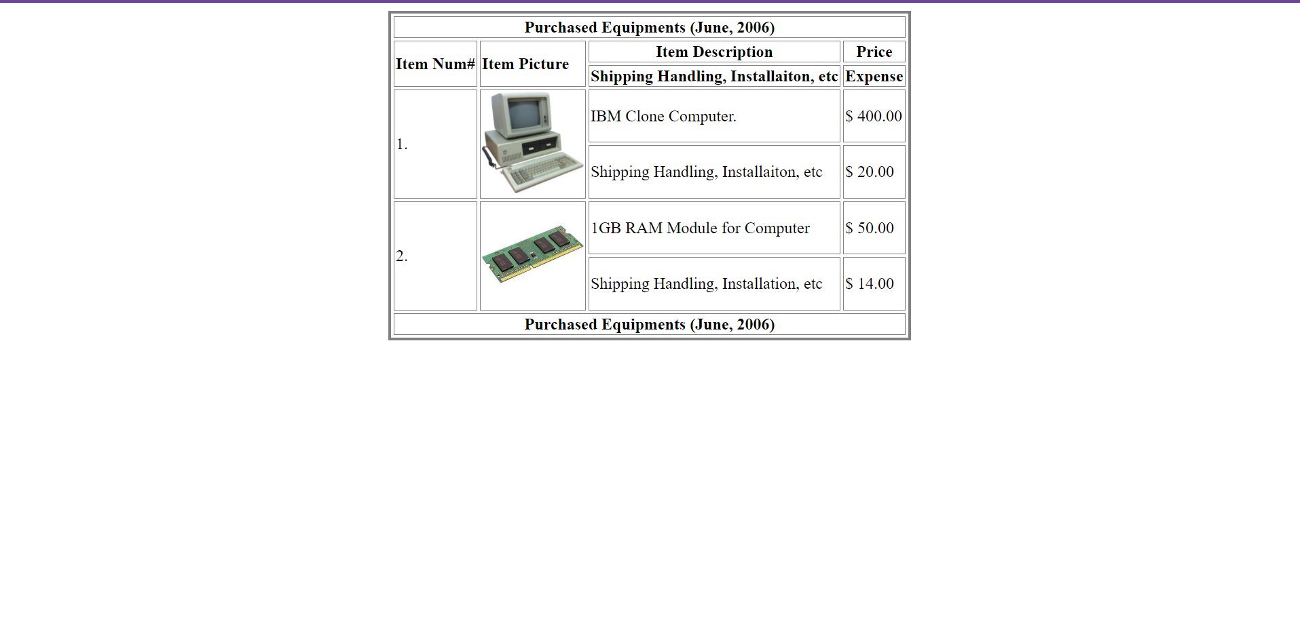

# Question 5)

Code:

<!DOCTYPE html>

<html>

<style>

body {

background-color: tomato;

padding: 0;

margin: auto;

}

.heading {

text-align: center;

font-size: larger;

padding: 1%;

background-color: whitesmoke;

}

.h2 {

text-align: center;

background-color: aqua;

margin: auto;

padding: 0%;

}

.form {

margin: auto;

display: flex;

justify-content: center;

}

.left {

margin-right: 10px;

width: auto;

text-align: right;

}

.right {

width: auto;

text-align: left;

}

</style>

<body>

<div class="heading"><h2>The World of Fruit</h2></div>

<div style="text-align: center"><h2>Fruit Survey</h2></div>

<form>

<div class="form">

<div class="left">

<p>Name</p>

<p>Address</p>

<p>Email</p>

<p style="padding-top: 10px">

how many pieces of fruit do you eat per day?

</p>

<br /><br />

<p style="padding-top: 8px">My favourite fruit</p>

<br />

<br />

<p style="padding-top: 8px">Would you like a brochure?</p>

</div>

<div class="right">

<p><input type="text" /></p>

<p><input type="text" /></p>

<p><input type="email" /></p>

<input type="radio" id="0" name="0" value="0" />

<label for="male">0</label><br />

<input type="radio" id="1" name="0" value="1" />

<label for="male">1</label><br />

<input type="radio" id="2" name="0" value="2" />

<label for="male">2</label><br />

<input type="radio" id="more" name="0" value="more" />

<label for="male">More than 2</label><br />

<br />

<select id="cars" name="cars" size="4" multiple>

<option value="volvo">Apple</option>

<option value="saab">Banana</option>

<option value="fiat">Plum</option>

<option value="audi">Pomegranate</option>

</select>

<br /><br />

<input type="checkbox" id="vehicle1" name="vehicle1" value="Bike" />

<br /><br />

<input type="submit" />

</div>

</div>

</form>

</body>

</html>

**Output:**

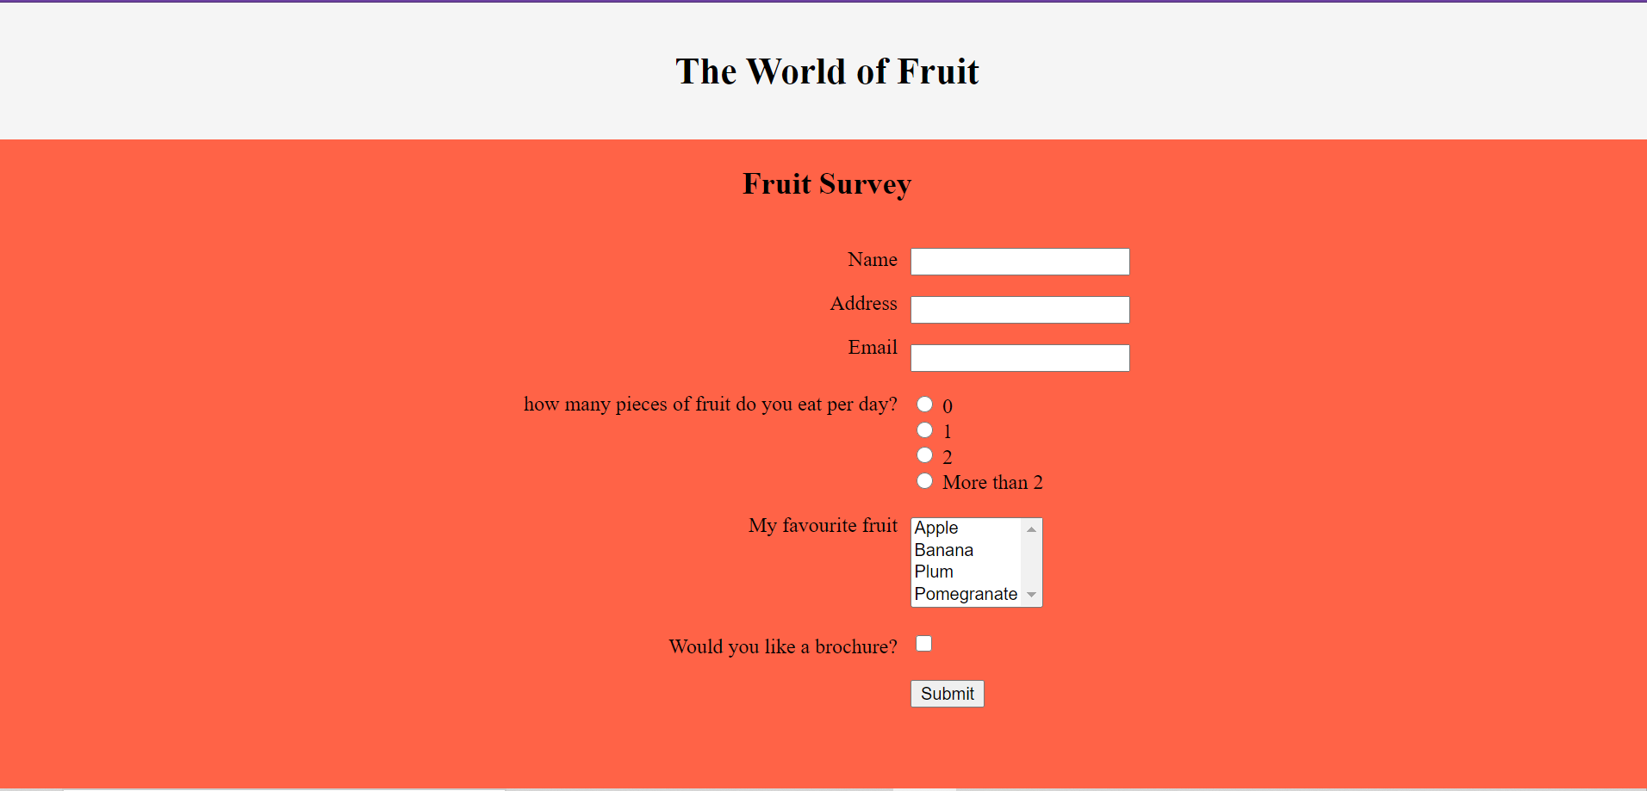

# Question 6)

**Code:**

h1{

color: tomato;

}

p{

color: green;

}

body{

background-color: whitesmoke;

font-weight: bold;

font: Verdana;

border: solid blue;

border-width: thin;

}

**Output:**

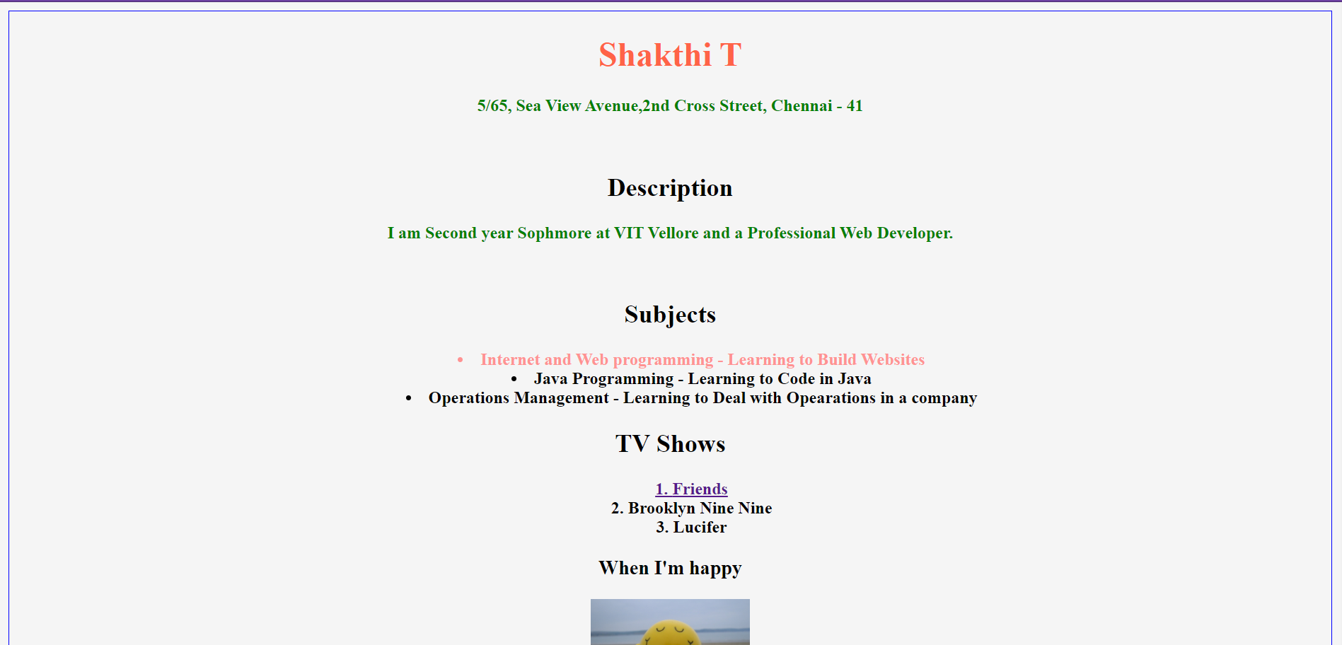

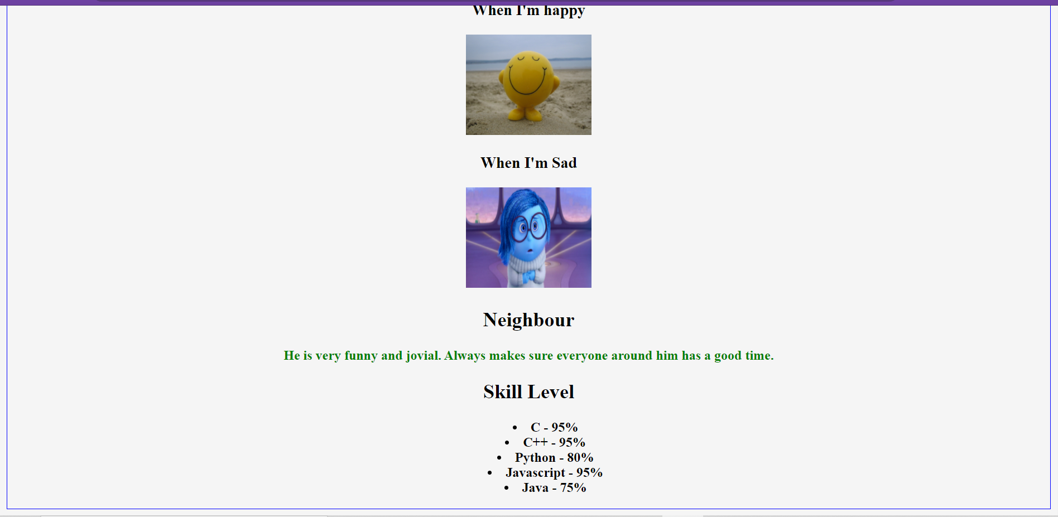

# Question 7)

Code:

HTML:

<!DOCTYPE html>

<html lang="en">

<head>

<meta charset="UTF-8">

<meta http-equiv="X-UA-Compatible" content="IE=edge">

<meta name="viewport" content="width=device-width, initial-scale=1.0">

<title>WALL-E</title>

<link rel="stylesheet" href="style.css">

</head>

<body>

<div id="all">

<h1>WALL-E</h1>

<p>

Walt Disney Studios Motion Pictures

Release date: Jun 27, 2008

</p>

<div id="menu">

<p>Summary</p>

<p>Critic Reviews</p>

<p>User Reviews</p>

<p>Details and Credits</p>

<p>Trailers and Videos</p>

</div>

<div id="pic">

<img src="https://upload.wikimedia.org/wikipedia/en/c/c2/WALL-Eposter.jpg" alt="walle" />

</div>

<div id="rating">94</div>

<div id="score">

<h2>Metascore</h2>

<p>

Universal acclaim <br />

based on 39 Critics

</p>

<ul>

<li>

Starring: Ben Burtt, Elissa

Knight, Jeff Garlin

</li>

<li>

Summary: After hundreds of

lonely years of doing what he

was built for, Wall-E

discovers a new purpose in

life when he meets a sleek

search robot named EVE. [Walt

Disney Pictures]

</li>

</ul>

</div>

</div>

</body>

</html>

**CSS:**

body {

background-color: grey;

}

h1 {

text-align: center;

}

#menu p {

background-color: black;

color: white;

padding-left: 20px;

padding-right: 20px;

display: inline;

margin-right: 3px;

}

#all {

position:absolute;

background-color: white;

padding: 20px;

width: 80%;

top: 10%;

left: 10%;

}

#pic {

margin-top: 50px;

}

#rating {

display: inline-flex;

padding:20px;

font-size:30pt;

background-color:green;

color:#eee7e7;

margin-top: 50px;

margin-left: 5px;

}

#pic {

float: left;

width: auto;

}

#rating {

float: left;

width: auto;

}

#score {

float: left;

width: 50%;

margin-top: 40px;

margin-left: 5px;

}

Output:

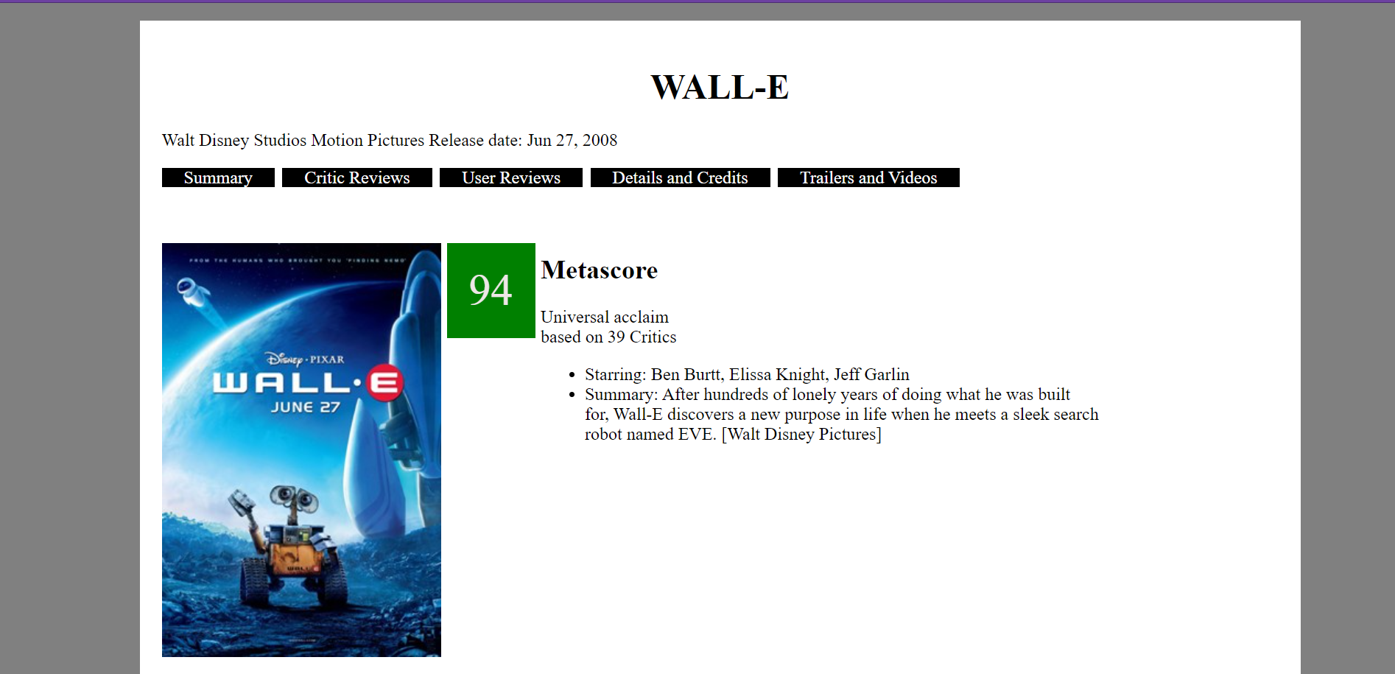

# Question 8)

Code:

HTML

<!DOCTYPE html>

<html lang="en">

<head>

<title>Question 8</title>

<meta charset="utf-8">

<meta name="viewport" content="width=device-width, initial-scale=1">

<link rel="stylesheet" href="style1.css">

</head>

<body>

<header >

<h2>World</h2>

</header>

<section>

<nav>

<ul>

<li><a href="#">London</a></li>

<li><a href="#">Paris</a></li>

<li><a href="#">Tokyo</a></li>

</ul>

</nav>

<article>

<h1>London</h1>

<p>Lorem ipsum dolor sit amet, consectetur adipisicing elit, sed do eiusmod tempor incididunt ut labore et dolore magna aliqua. Excepteur sint occaecat cupidatat non proident, sunt in culpa qui officia deserunt mollit anim id est laborum.</p>

<ul>

<li><a href="#">Museums</a></li>

<li><a href="#">Hotels</a></li>

<li><a href="#">Gardens</a></li>

</ul>

</article>

</section>

</body>

</html>

CSS:

* {

box-sizing: border-box;

text-decoration: none;

}

body {

font-family: Arial, Helvetica, sans-serif;

}

header {

background-color: #666;

padding: 30px;

text-align: center;

font-size: 35px;

color: white;

width:100%;

background-image:url("https://www.nlc.org/wp-content/uploads/2019/05/web_banner-3.jpg");

}

nav {

float: left;

width: 30%;

background: #ccc;

padding: 20px;

background-color : #FFFF99;

height: 300px;

}

nav ul {

list-style-type: none;

padding: 0;

}

article {

float: left;

padding: 20px;

width: 70%;

height: 300px;

}

a{

font-weight: lighter;

color: black;

}

a:hover {

font-weight : bold;

background-color: black;

color: white;

}

Output:

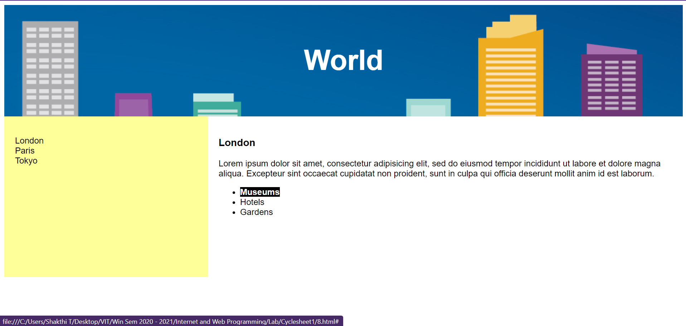

# Question 9)

Code:

<!DOCTYPE html>

<html lang="en" dir="ltr">

<head>

<meta charset="utf-8">

<title>Question 9</title>

<style media="screen">

.img1 {

margin: auto;

width: 25%;

padding: 10px;

border: 5px solid #4a47a3;

}

.video1{

margin: auto;

padding: 10px;

width: 25%;

}

</style>

</head>

<body>

<div class="img1">

<h1>Embedded Image</h1>

<embed type="image/jpg" src="T.jpg" width="250" height="250">

</div>

<div class="video1">

<h1>Embedded Video</h1>

<embed type="video/webm" src="movie.mp4" width="250" height="250">

</div>

</body>

</html>

Output:

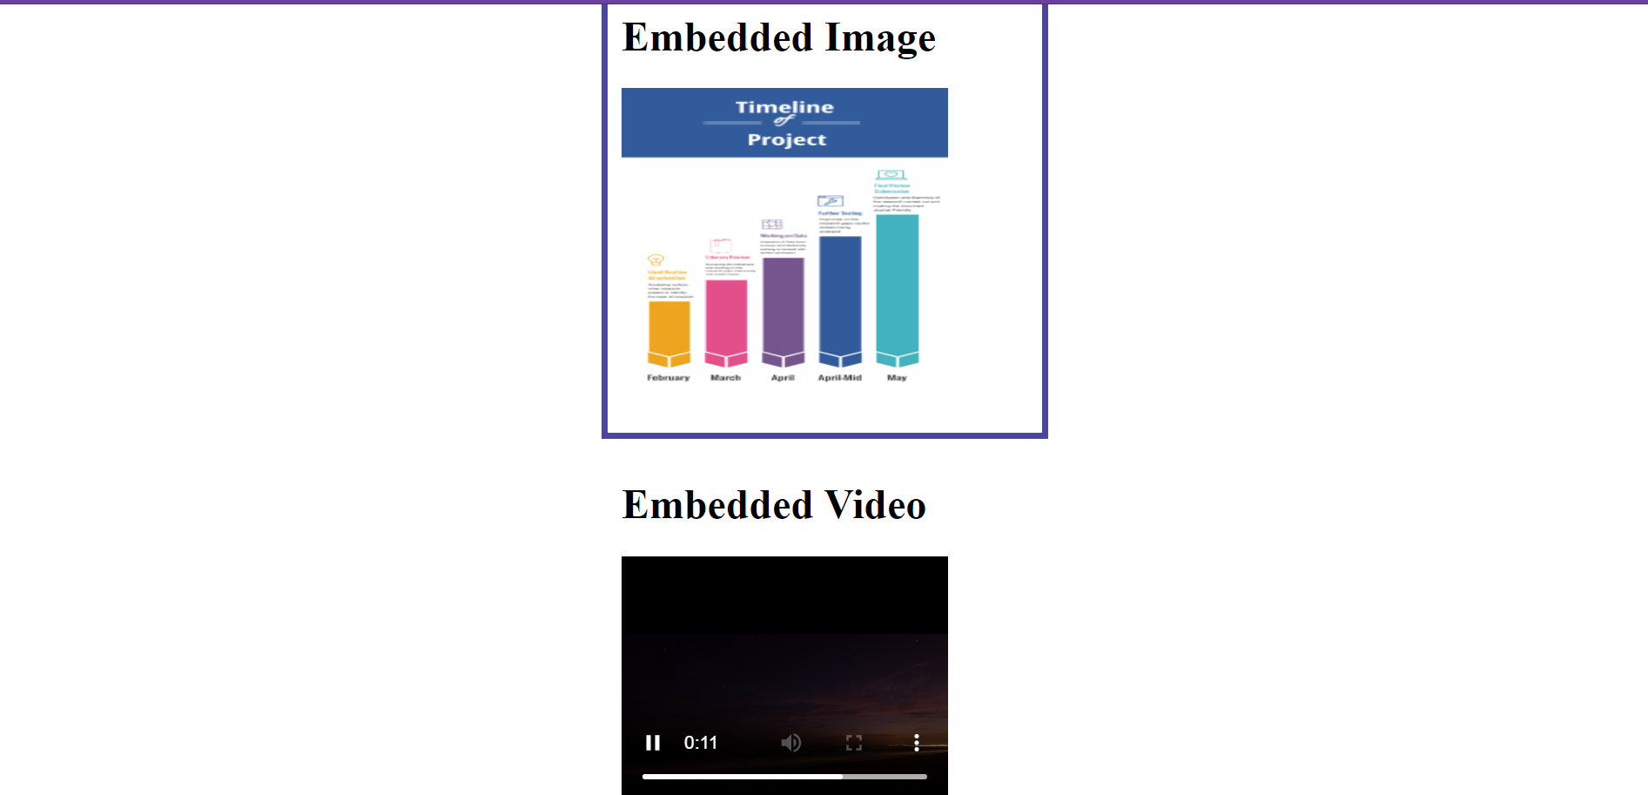

# Question 10)

Code:

<!DOCTYPE html>

<html>

<head>

<meta charset="utf-8">

<meta name="viewport" content="width=device-width, initial-scale=1">

<link rel="stylesheet" href="styles.css">

</head>

<body>

<div class="row">

<h1 class="title-1">Self control is the key to success</h1>

<h3 class="title-2">If you are able to achieve self control, you have won half the battle..</h3>

<div class="col-3 col-md-6" >

<div class="content">

<p>Lorem ipsum dolor sit amet, consectetuer adipiscing elit. Aenean commodo ligula eget dolor. Aenean massa. Cum sociis natoque penatibus et magnis

dis parturient montes, nascetur ridiculus mus. Donec quam felis, ultricies nec, pellentesque eu, pretium quis, sem. Nulla consequat massa quis enim.

Donec pede justo, fringilla vel, aliquet nec, vulputate eget, arcu. In enim justo, rhoncus ut, imperdiet a, venenatis vitae, justo. Nullam dictum felis

eu pede mollis pretium.

</p>

</div>

</div>

<div class="col-3 col-md-6" >

<div class="content">

<img src="Person.jpg">

<div class="picname">Name</div>

<p>Lorem ipsum dolor sit amet, consectetuer adipiscing elit. Aenean commodo ligula eget dolor. Aenean massa. Cum sociis natoque penatibus et magnis

dis parturient montes,

</p>

</div>

</div>

<div class="col-3 col-md-6" >

<div class="content">

<p>Lorem ipsum dolor sit amet, consectetuer adipiscing elit. Aenean commodo ligula eget dolor. Aenean massa. Cum sociis natoque penatibus et magnis

dis parturient montes, nascetur ridiculus mus. Donec quam felis, ultricies nec, pellentesque eu, pretium quis, sem. Nulla consequat massa quis enim.

Donec pede justo, fringilla vel, aliquet nec, vulputate eget, arcu. In enim justo, rhoncus ut, imperdiet a, venenatis vitae, justo. Nullam dictum felis

eu pede mollis pretium.

</p>

</div>

</div>

<div class="col-3 col-md-6" >

<div class="content">

<div class="blue">

aliquet nec, vulputate eget, arcu. In enim justo, rhoncus ut, imperdiet a, venenatis vitae, justo. Nullam dictum felis

eu pede mollis pretium.

</div>

<p>Lorem ipsum dolor sit amet, consectetuer adipiscing elit. Aenean commodo ligula eget dolor. Aenean massa. Cum sociis natoque penatibus et magnis

dis parturient montes, nascetur ridiculus mus. Donec quam felis, ultricies nec, pellentesque eu, pretium quis, sem. Nulla consequat massa quis enim.

Donec pede justo, fringilla vel,

</p>

</div>

</div>

</div>

</body>

</html>

CSS:

* {

box-sizing: border-box;

}

p {

background-color: #2f49dd;

width: 90%;

padding: 5px ;

margin-right: auto;

margin-left: auto;

font-family:'Times New Roman', Times, serif;

color: white;

}

h1{

text-align: center;

font-size: 66px;

margin-bottom: 0;

}

h3{

margin: 0;

text-align: center;

font-size: 31px;

}

.content{

border: 1px solid black;

background-color: #2f49dd;

height: 400px;

}

.row > div{

padding: 1%;

}

.row {

margin: auto;

width: 60%;

}

.col-3{

float: left;

border: 1px;

width: 25%;

height: 500px;

}

img{

display: block;

margin-top: 2%;

margin-left: auto;

margin-right: auto;

width: 90%;

height: 50%;

}

.picname{

background-color: red;

color: white;

text-align: center;

width: 90%;

margin: auto;

margin-bottom: 0;

}

.blue{

background-color: lightblue;

color: white;

padding: 2px;

margin: 2%;

}

Output:

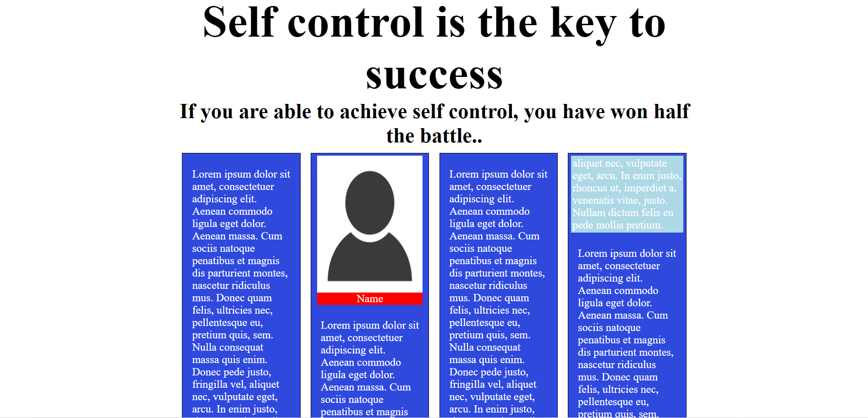

X------------------X